**Discord Subscription System Documentation**  
*Last Updated: [2025-02-23]*

1. **Overview**

This system allows server admins to manage premium subscriptions, assign subscription-exclusive roles, and create interactive role menus. Key features include:

* Add/remove user subscriptions with custom durations
* Create role selection embeds with buttons
* Manage subscription-linked roles
* Automatic role removal when subscription expires
* Premium role & subscription role management

1. **Difference in Premium role and Subscription role**

* **Premium Role**: The **core subscription role** that indicates a user’s subscription status.
* **Subscription Roles**: **Additional roles** that users can claim as part of their subscription benefits.

**You can think of this as:**  
Premium role is the main role which determine the user subscription status (If user has premium role, that means that the user has subscription)  
  
And Subscription role are those roles which can be added using buttons like (button roles). So, there can be multiple subscription roles in the server but there will be only one premium role. And if the roles are set as subscription role, only users with premium role can get those roles

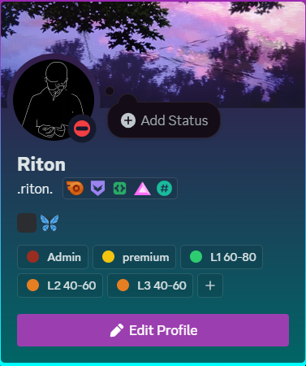

This is a premium role

These are subscription roles

1. **Setup Guide**
2. **Set premium role:** (Required before using subscription system)

**Command**: /set-premium-role [Role]

* Sets the main premium role for subscribers
* Users get this role when given a subscription

1. **Set Subscription Log Channel:** (Not required)

**Command**: /set-subscription-log-channel [Channel]

* Sets the subscription log channel for the server
* When user are added or removed subscription or removed automatically (after subscription duration ends), the bot will send notification in this channel

**How subscriptions work ?**

* Subscription will be automatically removed after the duration ends

1. **Core Commands**
2. **Subscription Management**

|  |  |  |
| --- | --- | --- |
| **Command** | **Parameters** | **Description** |
| /add-subscription | [User], [Duration] | Grants premium access to user for specified duration (e.g., "2wk") |
| /remove-subscription | [User] | Revokes subscription (and also remove premium role) and removes subscription roles if they are added by users via button roles. |
| /list-subscriptions | N/A | List all the active subscriptions in the server |

**Duration Formats**:

<number>sec/min/hr/day/wk/mo (e.g., "30day", "3mo", “4wk” etc)

1. **Subscription Role Management**

|  |  |  |
| --- | --- | --- |
| **Command** | **Parameters** | **Description** |
| /set-subscription-roles | [Template Message Link[ | Imports roles from message as subscription-locked roles |
| /clear-subscription-roles | [Template Message Link (optional)] | Clears ALL or message-specific subscription roles |
| /add-subscription-role | [Role] | Add single role to subscription roles list |
| /remove-subscription-role | [Role] | Remove role from subscription roles list |
| /list-subscription-roles | N/A | Lists all the subscription roles in the server |

**How Subscription Roles Work**:

* If any role is set as subscription role, users need active subscription (premium role) to claim these roles via buttons. But if the role is not set as subscription role, then the user doesn’t need active subscription (premium role) to claim the roles via buttons.
* Subscription roles are automatically removed if subscription expires.

1. **Role Message Creation**
2. **Setup**

**Command:** /create-roles-msg [format]

**Parameters**:

* **Template Message Link**: Message containing role categories/mentions
* **Channel**: Where to send the embed
* **Format**: Layout option (Divide/Format/Plain)

**Format Options:**

|  |  |
| --- | --- |
| **Option** | **Description** |
| Divide | Separate category per message |
| Format | Single embed with formatted categories |
| Plain | Direct copy of template message |

1. **Examples**

**Plain:**

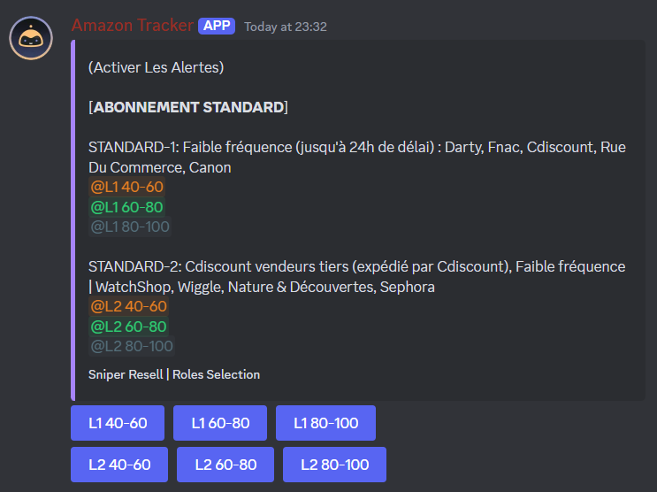

**Format:**

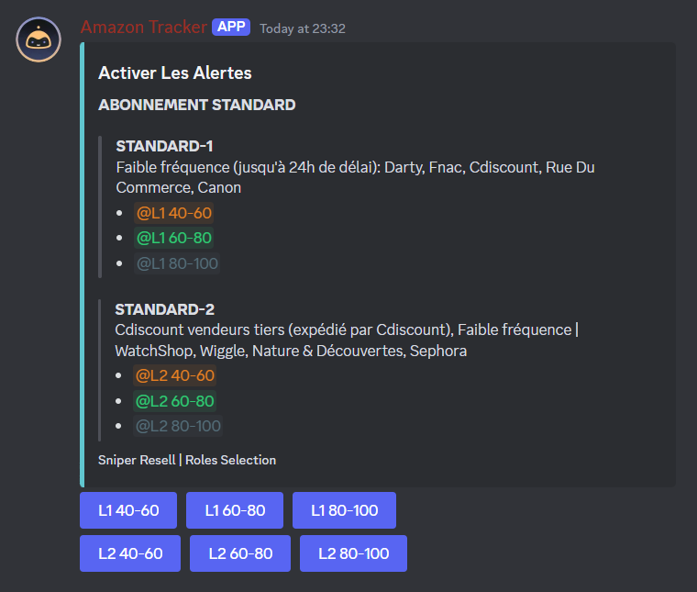

**Divide:**

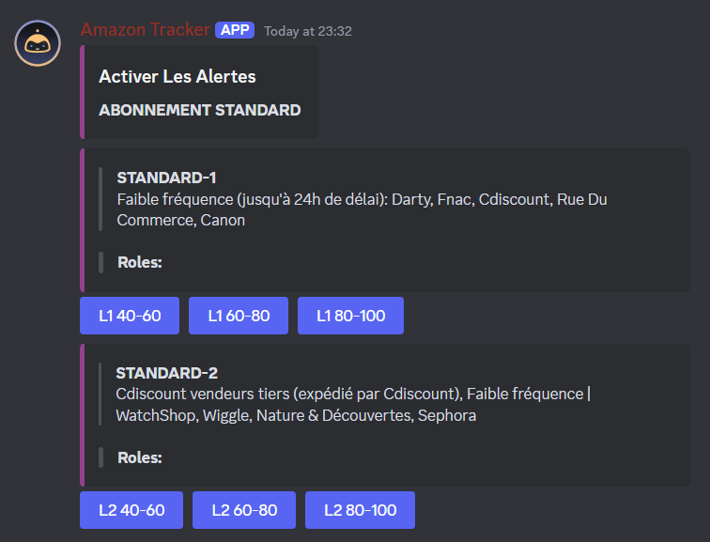

1. **How It Works**
2. **Subscription Flow**

* Admin uses /add-subscription → User gets premium role + DB entry
* User clicks role buttons → Bot checks active subscription
* If valid: Grants role | If expired: Denies access
* Scheduled checks remove expired subscriptions automatically

1. **Role Button Interaction**

* Users click buttons to self-assign roles
* Non-subscribers get error if trying to claim premium roles

1. **Troubleshooting**

|  |  |
| --- | --- |
| **Problem** | **Solution** |
| Bot can’t add roles | Ensure bot role is ABOVE target roles in Server Settings → Roles |
| Duration not working | Use exact format (e.g., "2wk" not "2weeks" etc) |
| Buttons not responding | Delete the existing roles message and create a new roles message using **/create-roles-msg** |

1. **FAQ**

* **Q: Do subscriptions auto-renew?**  
  No – admins must manually extend with /add-subscription.
* **Q: How to change premium role?**  
  Use /set-premium-role – existing subscribers keep old role until manually removed.
* **Q: Where are subscription logs stored?**  
  All actions are logged in your designated logging channel which are set using **/set-subscriptions-log-channel** command.